 

WTFPRICE SHOP ONLINE



**Thank for Teacher Guider Nguyen Quang Binh, Softech-Aptech Center and members of group helped to complete successfully this project !**

* Batch 106+108 – Group 3 .
* Guider : Mr. Nguyen Quang Binh .
* Member : Nguyen Huynh Tanh (Leader) .

Hoang Trong Bin .

Truong Thanh Than .

Nguyen Van Ngoan .

Table of Content

1. Definition of the Problem ………………………………………………………………………………………3
   1. Need ……………………………………………………………………………………………………………….3
   2. Overview of the solution ……………………………………………………………………………….3
2. Requirement analysis ……………………………………………………………………………………………..3

2.1 Process of order………………………………………………………………………………………………3

* 1. List of inputs to the system …………………………………………………………………………….3
  2. List of outputs expected from the system ………………………………………………………4
  3. Overview of process involved in the system ……………………………………………………4
  4. Use case and Actors …………………………………………………………………………………………5
  5. Technology, software required for implementing website ………………………9

1. Design ………………………………………………………………………………………………………………………9
   1. Design Database ………………………………………………………………………………………………9
   2. Design Interface, function modules, code criteria …………………………………………11
   3. Design GUIs …………………………………………………………………………………………………….11
2. Task sheet ………………………………………………………………………………………………………………30
3. Summary …………………………………………………………………………………………………………………30
4. Definition of the Problem :
   1. Need :

Today – Technology break out, shopping demand of people increase. And then, there favourable conditions to expand E-commerce, to go in with the World trend, WTFPrice: which is the website specialize to deal in audiovisual technology devices such as Smartphone, Laptop, Tablet,… open a shop to serve shopping demand of all people; to bring conveniently, quickly, confidence, above all others is economic effect, save on money.

* 1. Overview of the solution :
* Purpose of Website: Customer can view, look up, order, feedback, shopping cart, personal information management on way convenient, exactly, and reading news article technology of world.
* Modeling the objects of the issue into Database follow direction with the Real-World .
* Easily manipulate , handle, caculator, add new, edit, update, storage, ...
* Manage your data in the relational model is based on the table to bring the integrity and synchronization of data .
* Encapsulation data, and authorization access to solve issues of data security.
* Design each Modul of each object type and function offer easly maintenance and repair later.
* Interface optimized and is suitable for the use and management .
* Optimize new technology to bring a quality product with reasonable price.

1. Requirement analysis :
   1. Process of order:

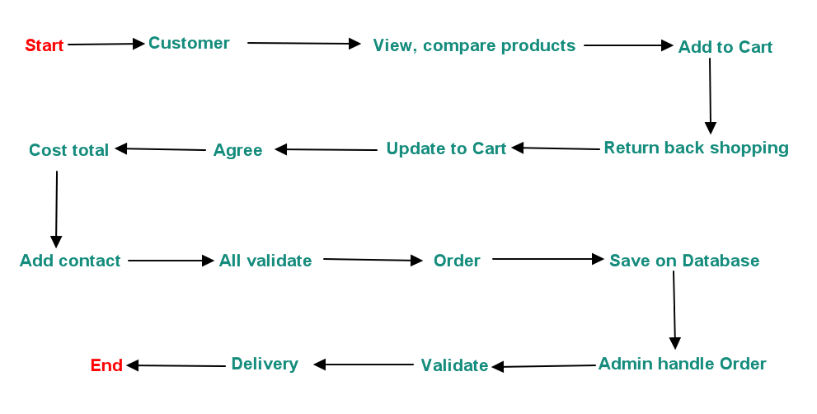

* 1. List of inputs to the system :
  + Product information : ID, Name, Description, Price, Stock , Image, Category,…
  + Category information : ID, Name, Description,…
  + Manufactor information : Id, Name, Description .
  + Order information : ProductId, Contact, Quantity,…
  + News information : ID, Title, Description, Image, Createdate, Views,…
  + NewsCategory information: ID, Name, Description,…
  + Feedback information : D, Name, Content, Contact,…
  + User Information : ID, UserName, Email, Password, PhoneNumber,Image,...
  1. List of outputs expected from the system :
  + Tables data of process Add, Update, Delete, Search, … information .
  + Fields data of process Add, Update, Delete, Search, … information .
  + Orders after handle.

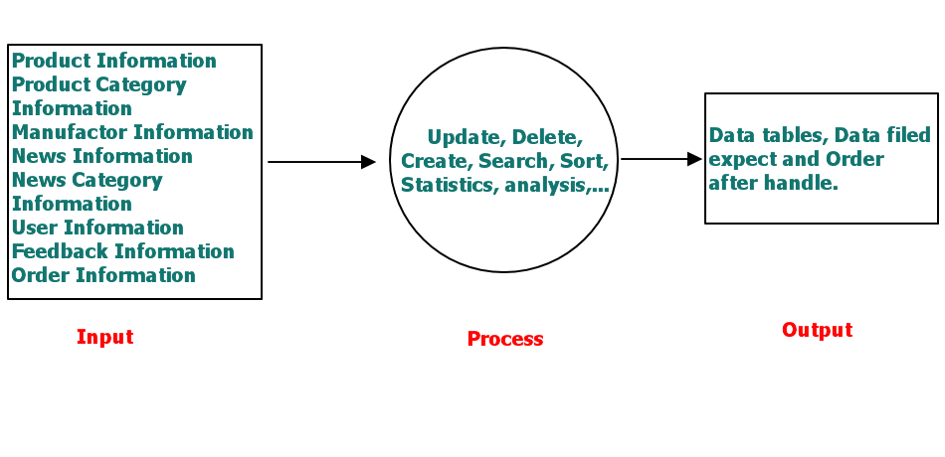

* 1. Overview of process involved in the system :
  + View .
  + Compare.
  + Order.
  + Update .
  + Delete .
  + Search .
  + Login .
  + Logout .
  + FeedBack .
  + Change Password .
  + Permission .

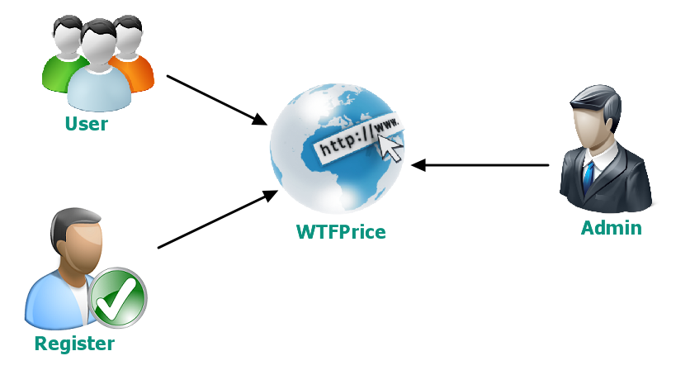

* 1. Use case and Actors :

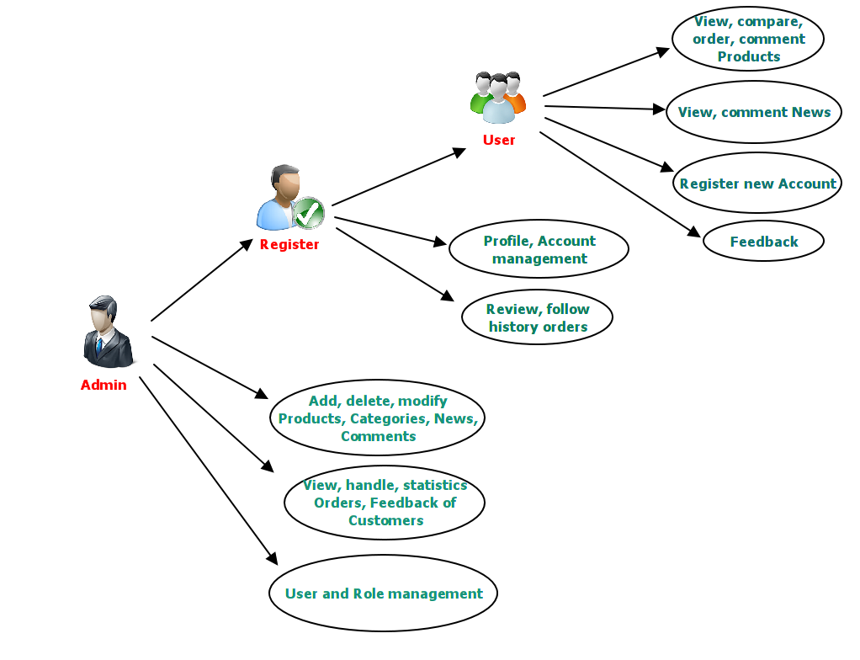

1. User :

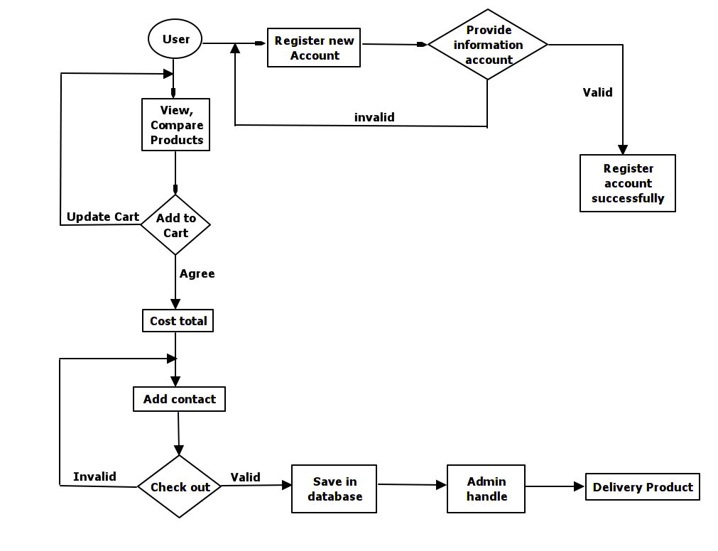

**.** **User description:**

* The first, User can browse webpage, and then user can view, compare, comment products.
* If user has demand buy products, who can click “Buy” button to buy products, also user can return back webpage to continuous shopping and update shopping cart.
* After buy products, user already agree check out, cost total, and provide another contact information such as Name, Address, PhoneNumber,…
* If contact information invalid, we require re-enter until contact is valid.
* Finally, User can complete process order products.
* In addition, user can register along with website to follow account information and view shop history.

1. register :

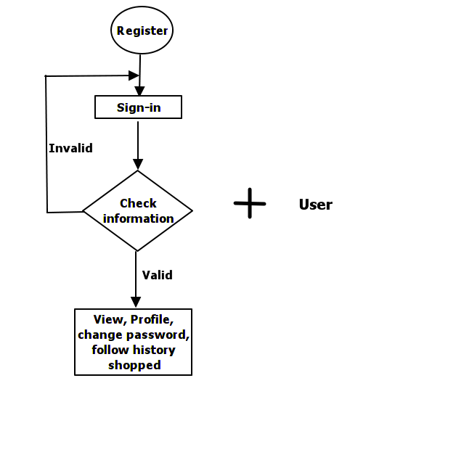

**. Register description :**

* Register have all of User function.
* The first, register login with UserName and Password with role already provide.
* And then, Main function of register is management of account information, change password, follow order history, and status product delivery.

1. Admin :

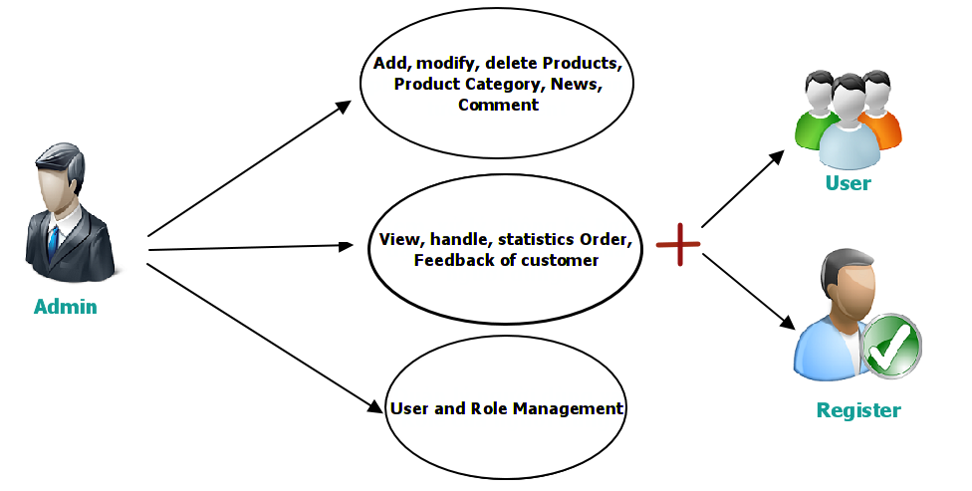

**. Admin description :**

* Admin have all of User and Register function.
* The first, Admin log in into website with UserName and Password with role Administrato.
* After login into website, Admin can have all permission of website:
  + Add, modify, delete of product, product category, manufactor, news, news category, comment.
  + View, handle, statistics order, feedback of customers.
  + User and Role Management.
  1. Technology, Hardware and software required for implementing website .

1. Technology :

* Server side: Website using ASP.NET MVC 5, the lastest technology of Microsoft .
* Client side: Website using HTML5, CSS3, Javascript, another library such as bootstrap, jquery,…

1. Editor Sofware :

* Visual Studio 2013, SQL Server 2012.

1. Enviroment deploy: IIS 8.0.
2. Hardware of server and client: Website deploy and run any device hardware current.
3. Design :

3.1 Design Database :

* Database comprisse 14 tables, what constrainted by Foreign-key constraints .
* Every table is a entity set of objects in system, comprise a Primary-key and properties .

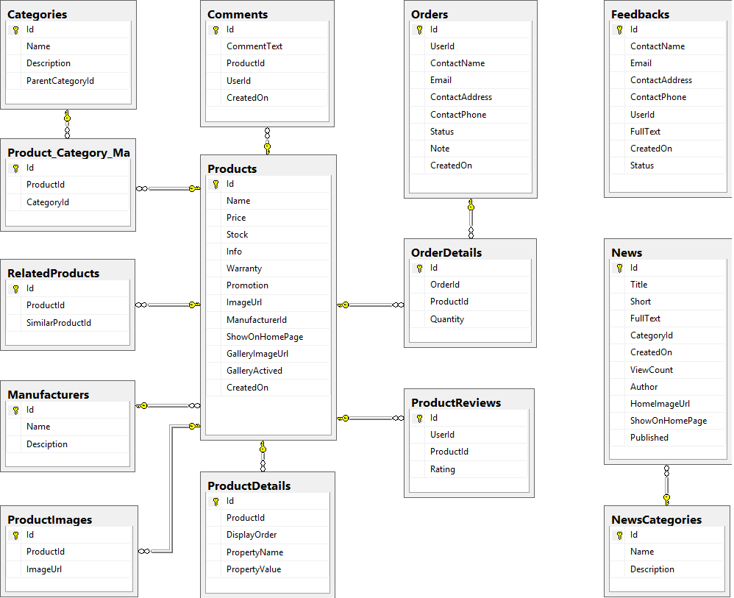

3.3 Design GUIs :

a. Home Page :

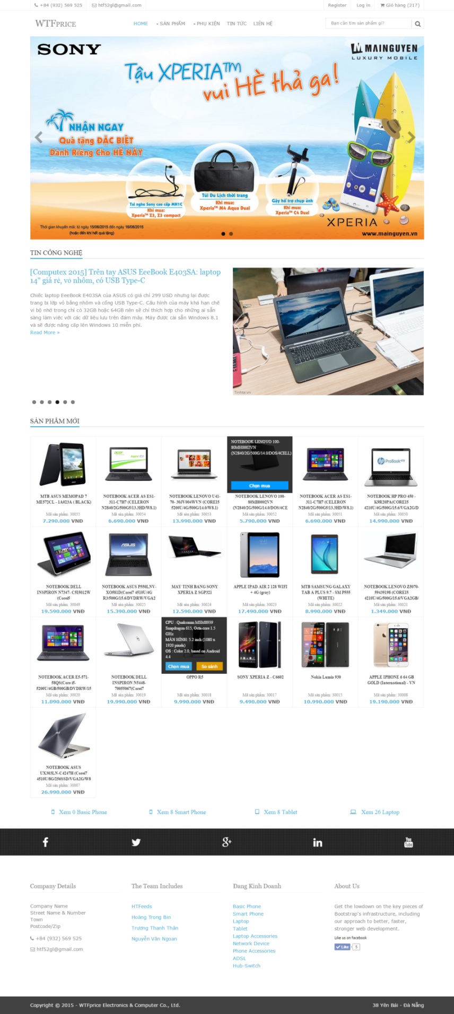

1. Product Details :

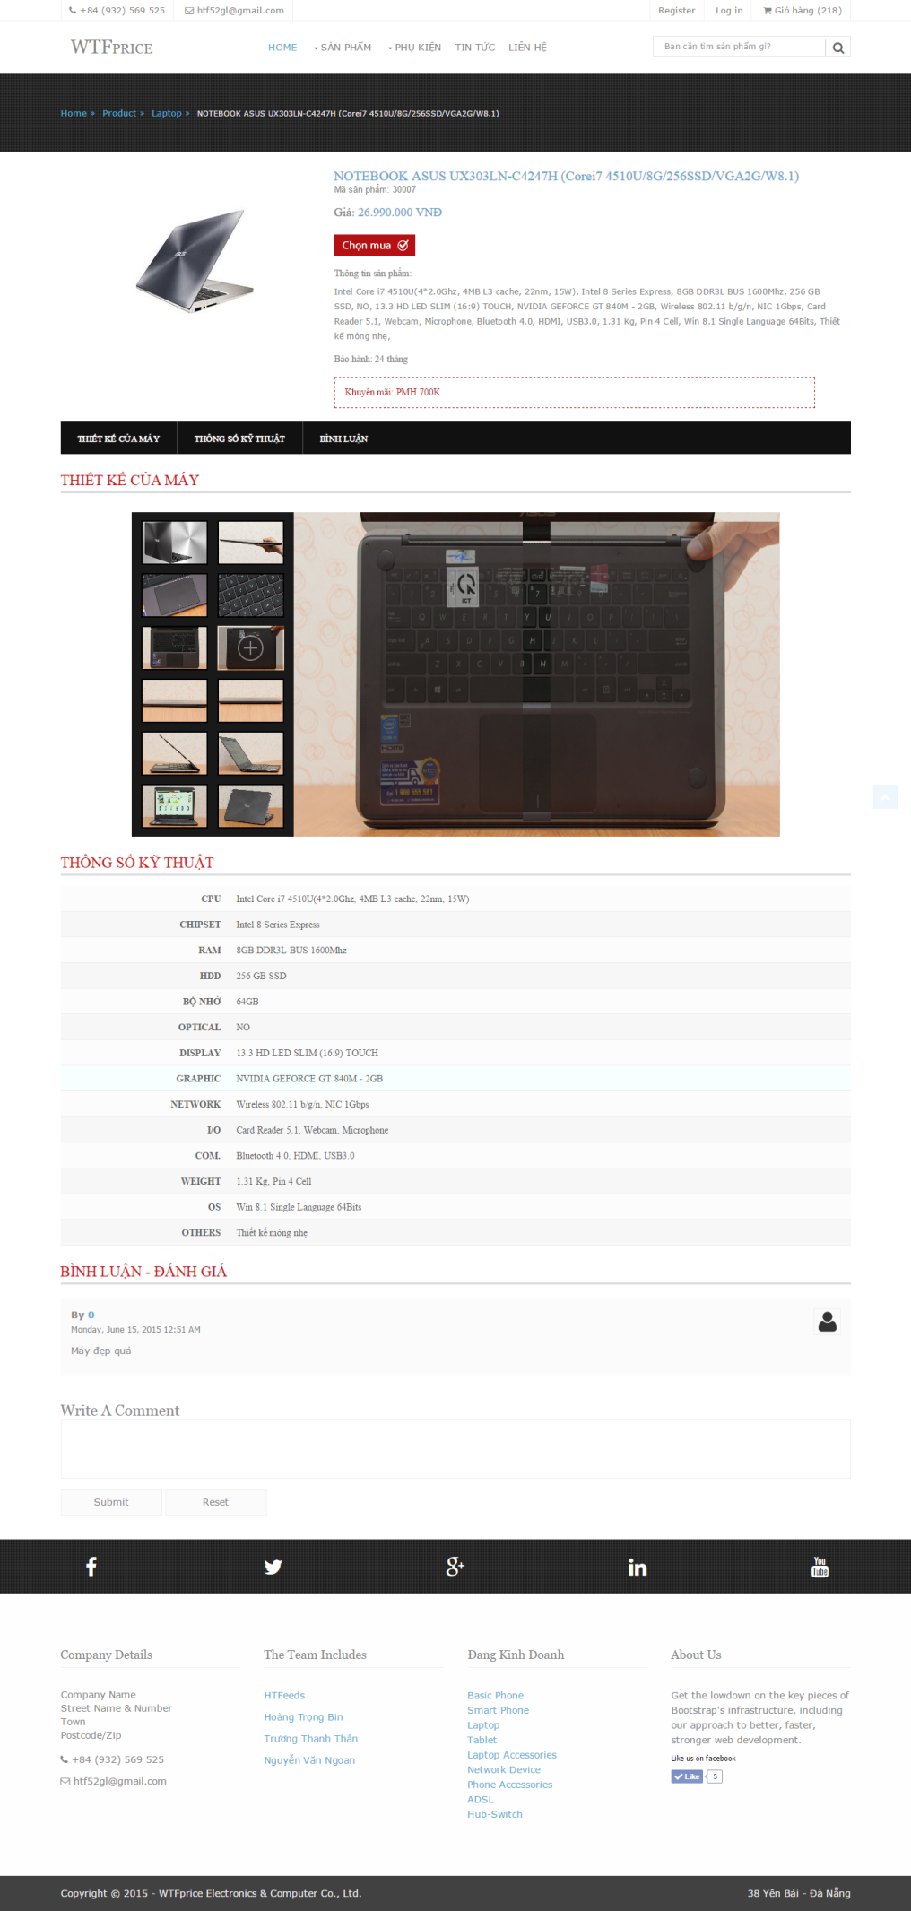

Shopping Cart :

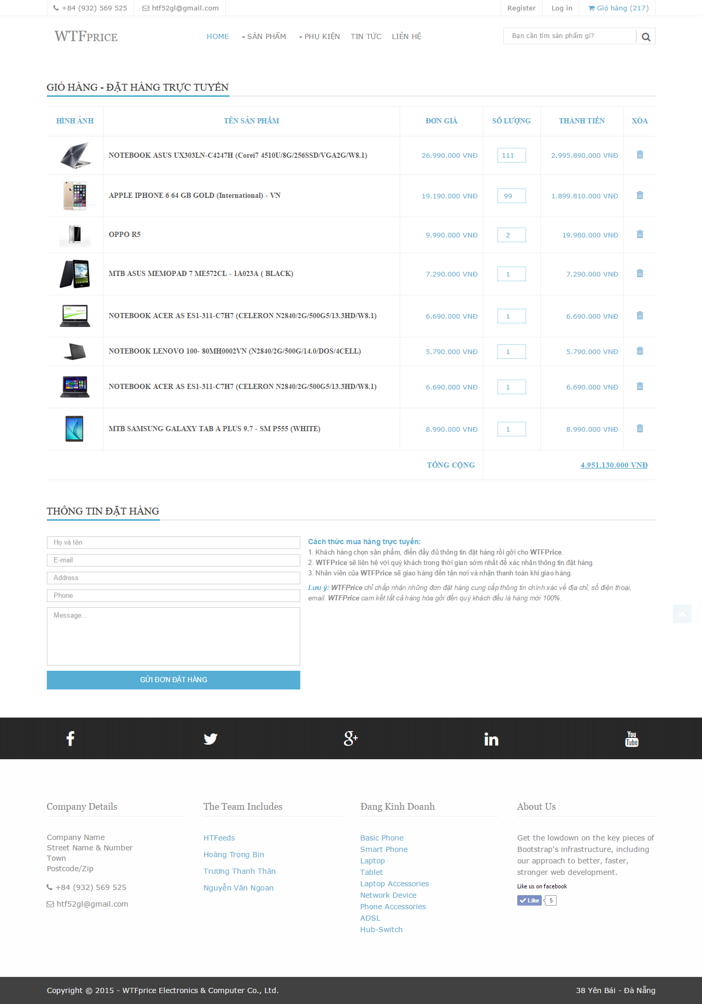

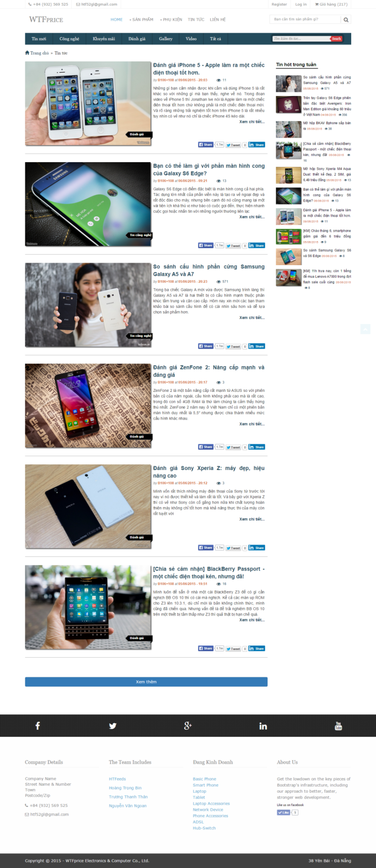

1. News Details :

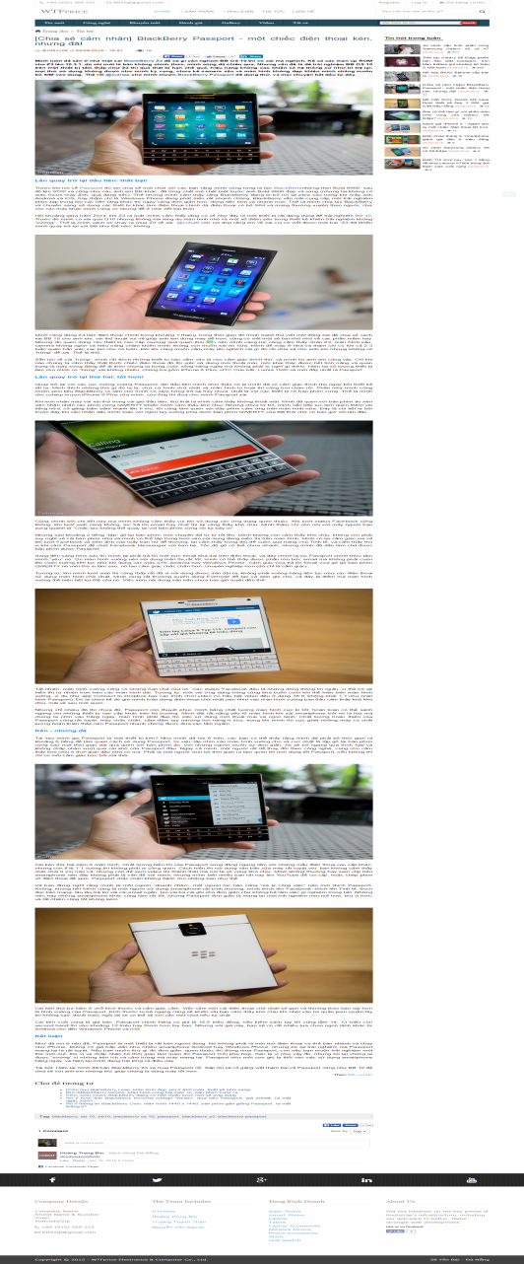

1. Contact :

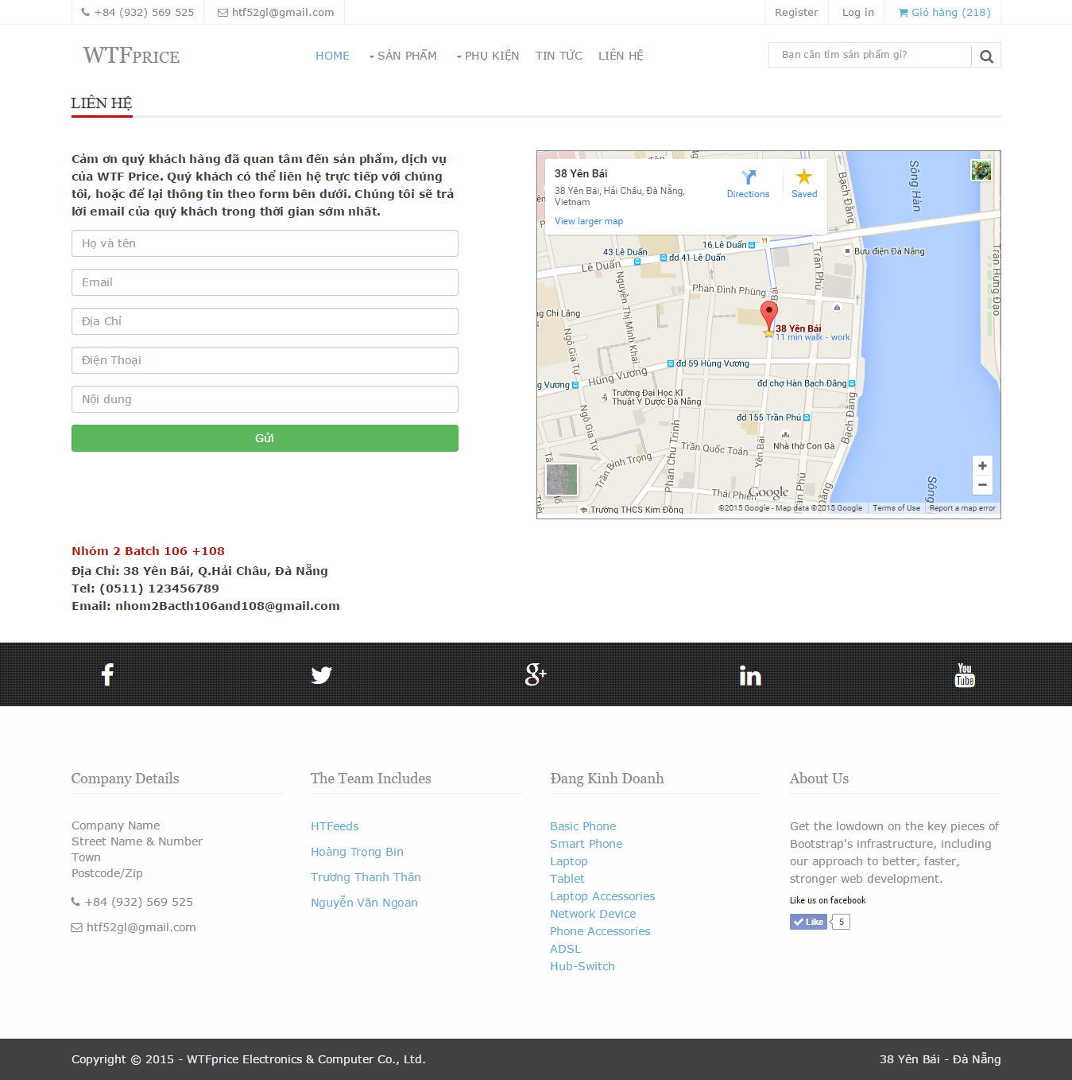

1. Login :

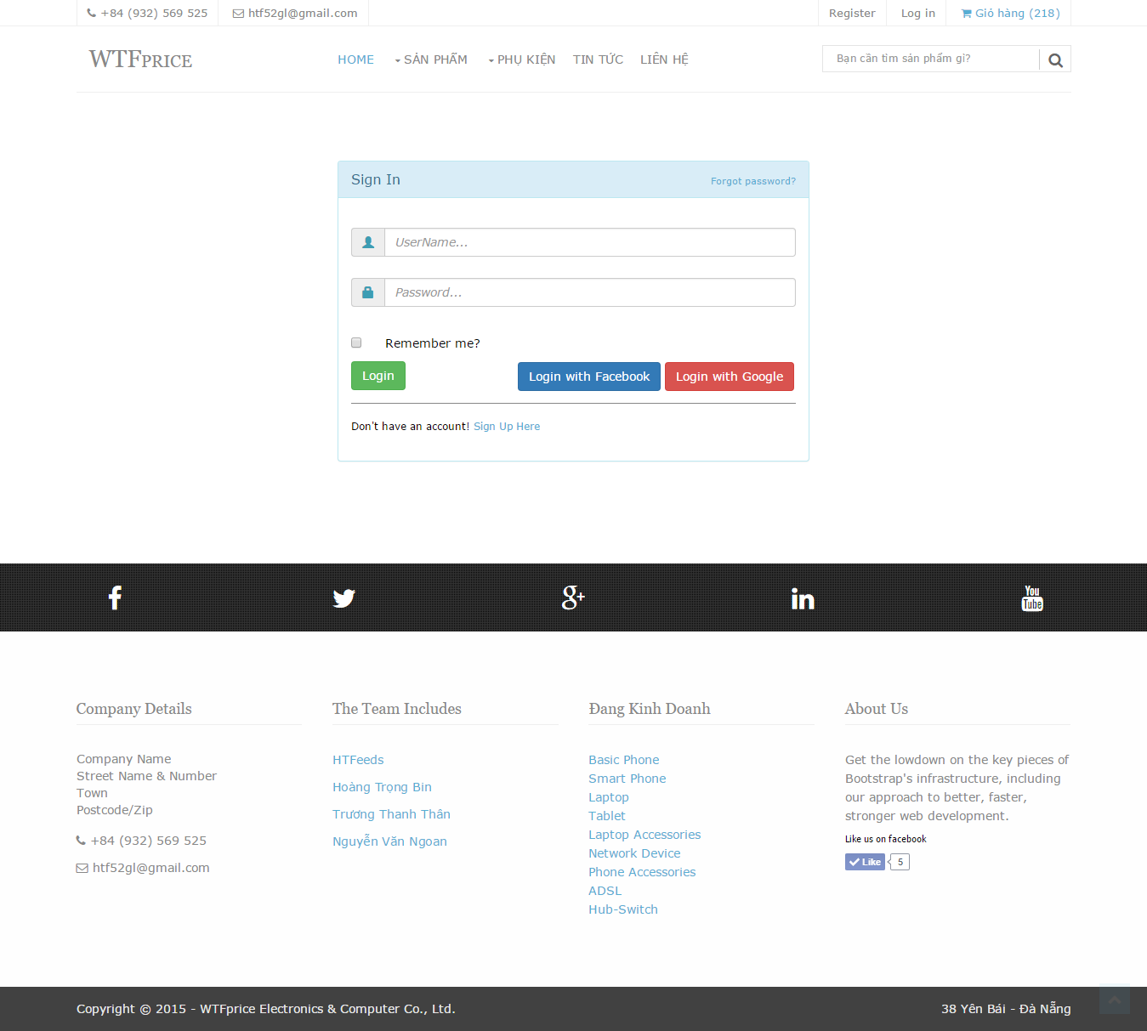

1. Task sheet :

|  |  |  |  |  |
| --- | --- | --- | --- | --- |
| STT | Author | Duration | Task | Note |
| 1 | Nguyen Huynh Tanh | 19-21/05/2015 | Choose Topic |  |
| 22-23/05/2015 | Look up document |  |
| 24-26/05/2015 | Design Ui:  - User layout  - Homepage  - Product list page  - Product detail page |  |
| 27/05/2015 | - Design database  - Usercase |  |
| 28-1/06/2015 | - Home controller  - Product controller |  |
| 02/6/2015 | - Admin layout |  |
| 03-05/06/2015 | - Comment controller |  |
| 06-08/06/2015 | - Product detail action method |  |
| 09-11/06/2015 | - Order controller |  |
| 12-17/06/2015 | Admin management:  - Product  - Category  - Order  - Mapping  - Related |  |
| 2 | Hoang Trong Bin | 24-28/05/2015 | - News ui |  |
| 29-4/06/2015 | - News management |  |
| 05-8/06/2015 | - News controller |  |
| 9-14/06/2015 | - Login |  |
| 15-17/06/2015 | - Report |  |
| 3 | Truong Thanh Than | 24-4/06/2015 | - Feedback page  - Feedback controller  - Feedback management |  |
| 5-12/06/2015 | - Comment management |  |
| 13-17/06/2015 | - Add database |  |
| 4 | Nguyen Van Ngoan | 24-29/05/2015 | - Look up document  - Ui comparer |  |
| 10-17/06/2015 | - Comparer controller  - Product reviews management  - Manufacturers management |  |

1. Summary :

* With this WTFPrice website, we hope help people to shopping quickly, effect, exactly, save on time and money .
* If have problem of this website, we available maintain and upgrade follow expected .
* This application is the result of a concentrated effort of Guider and Members, but still deficient .
* We will be glad to receive your suggestions to website better .

Thank you teacher and all everyone followed this presentation !